**Explanation of application design**

First of all I used the divide and conquer strategy to break the problem down into more manageable sub-problems.

**Divide and Conquer**

1. Find Number(N) to be tested
2. Determine the divisors of N.
3. Check to see if the divisors add up to N

I then focused on the first of these sub-problems.

After some extensive research I found all perfect numbers to date have followed the Euclid – Euler theorem which states, every perfect number can be represented in the form (2^n-1 )(2^n - 1), where (2^n - 1) is a prime number.

This theorem can only result in even perfect numbers, so the first of my solution is to check if N is an even and a positive number.

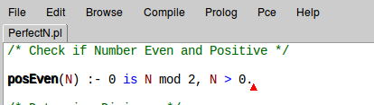

I decided to use Divide and Conquer again to break the second sub problem into even smaller, more manageable problems.

2. Determine the divisors of N

1. Create list (FL) of factors of N.
2. Sum list of factors (FL)

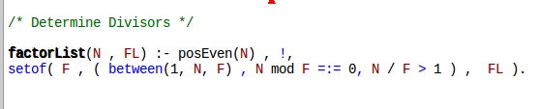

To begin with I created a rule to get the list of factors for N. Firstly I used the posEven rule I set up in the first step to ensure N was a positive and even number. Then I used the mod operator to ensure F was a factor of N and since I didn’t want N in my list of factors(FL) I made sure that F divided into N more than once.

I used prologs built in predicates ‘between’ to check that F is in the range 1 to N and

‘setof’ to sort the list and to get rid of any duplicates that may have been added to the list.

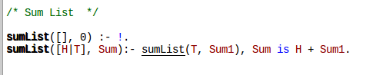

I then set up a rule to return the sum of a list. I found this fairly straightforward as it was fairly similar to the questions we did on lists in Lab 3 of this module.

3, Check to see if Divisors add up to N

1. If Sum of FL = N, return ’True’, N is a perfect number!
2. Else return ‘False’, N is not a perfect number.

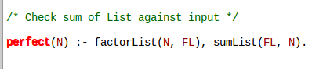

The final step of my application was simply putting the previous two steps of my solution together to check if N is a perfect number.

**References**

**Websites:**

Perfect number. *Encyclopedia of Mathematics.* URL: http://www.encyclopediaofmath.org/index.php?title=Perfect_number&oldid=35528